Imagine that you and another developer are tasked with two parts of the same software

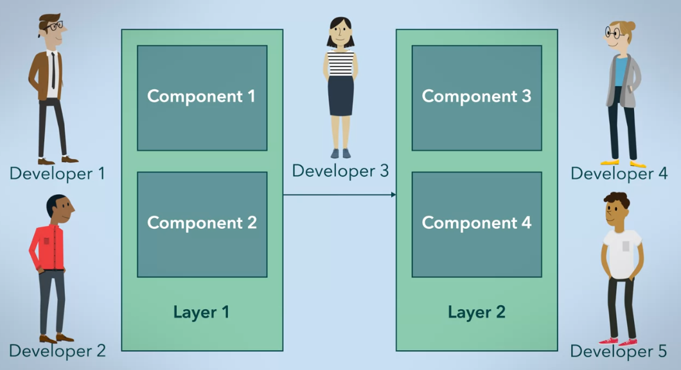

Looser organizational structures, such as in open-source projects, led to more loosely-coupled modular code – a study at the Harvard Business School by MacCormack and others (2007)

**Conway’s Law**

* A system will tend to take a form that is congruous to the organization that produced it

Putting a team together without regard to Conway’s Law may lead to unintended consequences

Web Development

* n-Tier (3 Tier)
  + builds data backend
  + builds the application logic layer
  + builds the presentation tier